Parish Name and Address | Photo
St. Jacob of Alaska  Orthodox Christian Church  155 N.E. Greenwood Ave.  Bend, OR 97701  (photos shows the property in escrow for parish’s future home) | 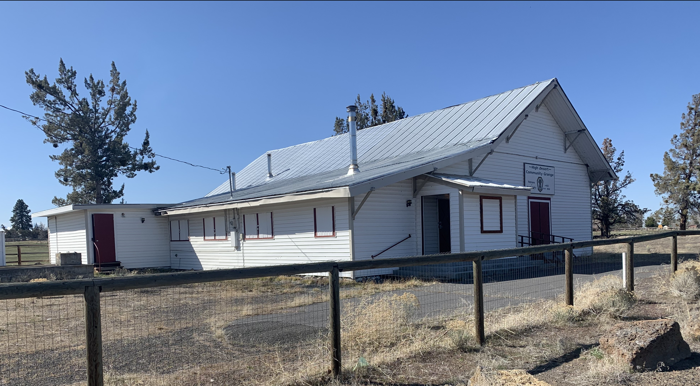

Clergy
Rev. Ignatius Strange

Committees/Societies
Parish Council is the focal point for coordinating various ministries and service groups
- Organizing the beginning stages of a dozen ministries and service groups to improve all parish functions.
- Oversight of the Building Committee; with a new church facility acquisition
- Sunday School, which began in September for the first time at St. Jacob
- Hospitality teams for meal prep, greeters and special events.
- Developing ‘social time’ together (small group dinners, playgroups for children) as brothers and sisters in the Faith, is begin organized. It works to welcome new people and help young families find mutual support.

Since August 2021

Highlights of Top Three Activities
- Growth in the wake of the Covid Shutdown. The changes in modern culture and local organizations has prompted young people (single and families) to look for a community of Christians as a support. Our response to inquirers and new members has focus on finding a way to involve new and old alike a dozen unfolding ministries within the parish
- Launching Catechesis of the Good Shephard Sunday School for the 4-7 year old age range. With a rapid uptake of new young families, the focus on the parish has adjusted to providing a church environment that welcomes inquiring families while including their young children
- Acquisition of a new Property for our future parish home. We are both at the limits of occupancy in our current location and in the last year of the lease. A recent push to find ‘something, anything’ that was affordable has led us to the purchase of the historic High Desert Community Grange, sitting on one acre and surrounded by farmland.

Outreach and Charitable Activities
Agia Sophia, as St. Jacob Parish’s face to the community, has begun to transition away from housing the worship space for St. Jacob, giving it a distinctly Church/Mission flavor. The church’s near-term move to a new property will give the Coffee Shop & Bookstore a new identity as it blends its Coffee Shop identity with books and community meeting space . . . now as an ‘outpost’ of St Jacob’s presence in Bend.
Parish outreach will be consumed this next year with renovating the new space and letting people know about our transformation of a historic Bend property, and the existence of the Orthodox Church.

Major Challenges Faced

Upcoming Special Events/Anniversaries - August 2021 to September 2023

 | Reported for  Calendar Year  2020 | Reported for  Calendar Year  2021 | As of July 1,  2022
Active Members Count | 41 | 55 | 61
Children (under 18) | 17 | 30 | 30
 | Reported for  Calendar Year  2020 | Reported for  Calendar Year  2021 | January 1 thru July 1,  2022
Average Sunday Divine Liturgy Attendance | 26 | 36 | 55
Average Sunday Divine Liturgy Communicants | 20 | 30 | 45
Average Saturday Vigil Attendance | 8 | 8 | 10
Number of Catechumens | 7 | 10 | 18
 | Reported for  Calendar Year  2020 | Reported for  Calendar Year  2021 | January 1 thru July 1,  2022
Baptisms | 2 | 5 | 10
Funerals | 0 | 0 | 0
Marriages | 1 | 1 | 1
Receptions into Orthodoxy | 0 | 0 | 0
Church School/Number Enrolled | n/a | n/a | 10
Adult Education/Number Participating | 16 | 19 | 22

